Merchant Enrolment TDD
V 1.0
SachinKumar Nikumbha
7-12-2016

TABLE OF CONTENTS
1 Introduction 1
1.1 Purpose 1
1.2 Scope 1
1.3 Definitions, Acronyms and Abbreviations 1
1.4 References 2
2 System Overview 3
2.1 System Characteristics 3
2.2 System Architecture 3
2.3 Infrastructure Services 4
2.4 Process Overview 4
3 System Design 6
3.1 Design Method and Standards 6
3.2 Documentation Standards 6
3.3 Naming conventions 6
3.4 Programming Standards 6
3.5 Software development tools 6
3.6 Outstanding Issues 6
3.7 Decomposition Description 6
4 Component Description 7
4.1 Component Identifier 7
5 Software Requirements Traceability Matrix 9
Document Control 10
Document Signoff 10
Document Change Record 10

1 Introduction
- The ME Portal (“MerchantEnrolmentPortal”) is a .Net 4.5 Web UI developed using MVC framework. The purpose of this UI is to help external Merchant to upload details.
- The portal serves as an interface for the merchant to enrol.
- The UI is connected with multiple technologies for the complete end to end flow to work.
- The “MerchnatEnrolmentWebApi” service is ‘RESTful’ service which is consumed from ME UI portal for processing activities.

Purpose

The purpose of this document is to give complete overview of the ME portal and api services in terms of technology, workflow and other tools used.

This document will detail the list of all the tools and technologies used in the applications for the end to end transaction happen and also will detail the list of required be the Lead .net developer to perform day to day activities and understand the process end to end.

Scope
          - This system will enrol the merchant based on the rules defined for enrolment.
          - Admin can change the rule of enrolment and it will be applicable to all the members which will be getting enrolled after that.

Definitions, Acronyms and Abbreviations

- The following is a list of definitions for this template based on the UML approach to system design:

Class Diagram | Describes the structure of a system
Object Diagram | Expresses possible object combinations of a specific Class Diagram
State chart Diagram | Expresses possible states of a class (or a system)
Activity Diagram | Describes activities and actions taking place in a system
Sequence Diagram | Shows one or several sequences of messages sent among a set of objects
Collaboration Diagram | Describes a complete collaboration among a set of objects
Use-case Diagrams | Illustrates the relationships between use cases
Component Diagram | A special case of a Class Diagram used to describe components within a software system
Deployment Diagram | A special case of a Class Diagram used to describe hardware within the overall system architecture
System Block diagram | A diagram showing the major components of the system with its interconnections and external interfaces

References

Num. | Title (Applicability & Reference) | Author | Date | Issue

System Overview
Global merchant enrolment service that will be used across various countries to enrol merchant details, the system should provide below features –
- Search by Merchant Name or by Country which will return a list of merchant details
- Add new merchant details
- View merchant details
- Edit merchant details
- Delete merchant details

System Characteristics

System Architecture
- The system based upon an n-tier, MVC architecture. It is possible that the architecture will have secure managed interfaces or proxies to isolate systems from illegal access. (Not implemented yet in poc code of MEPortal and API). The Architecture may be a simple client-server system in which web technologies are used to provide forms from a simple server that can be filled in remotely by someone. With a simple requirement to collect basic information, which can be entered as it is captured by the user.
- The access layer is designed in MVC platform where user can access views to upload the merchant information. Also Admin can define the rules for different countries to Merchant enrolment.
- The business layer is Web API RESTful services, in business layer we implemented IOC with dependency injection. Dependency injection is one way to implement inversion of control.
Dependency injection injects the dependencies of a class at runtime. This creates a lose coupling between the classes as changes in one class does not impact the other dependent classes. To automatically inject dependencies we use a Dependency Injection (DI) container. When we managed dependencies by the container we can get benefit of Automatic Dependency Resolution and there are less chances of error. We used Unity to managed dependencies.
- In current solution we manage data in collection, but with few changes we can replace collection with Actual data layer classes and post data to SQL or oracle db.
- The architecture proposed is a tried approach that, when implemented, will provide the flexibility to support ever-changing business requirements. Its key feature is that it separates out business logic, client access technology and centrally held data into discrete layers with standard, open interfaces. Today n-tier architectures can often be divided into several tiers as follows:
          - client or ‘access’ tier – which facilitates access by both external and internal clients through technologies such as web browsers
          - presentation tier – the layer that accesses information from the other systems as required, and can contain its own ‘business rules’ for simple processes
          - business tier – contains the business information layer
          - Persistence tier – the database layer, which provides the facilities to store data.

Infrastructure Services
- We have some infrastructure Services which we will provided to all application level to use, with a view to reducing the time, cost and risks of development through re-use. The Infrastructure Services built incrementally, implementing the most common requirement, followed by more specialised services. In this section will include:
          - Security
          - Audit
          - Performance monitoring and reporting
          - Error Handling – Implemented
          - Debugging
          - Logging.

Process Overview

ME stands for Merchant Enrolment.

User can navigate to Merchant Enrolment Portal by going to link – “http://localhost:65474/” using web browser. On landing page he can view the list of existing enrolled Merchants.

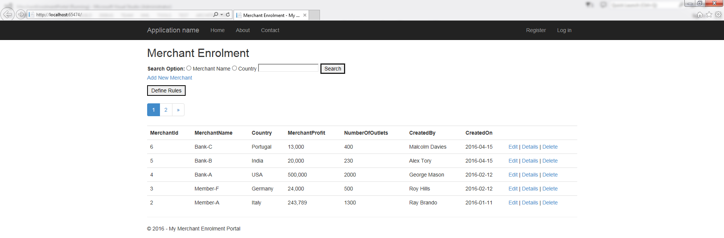

As a part of business requirement, business can enrol merchant from globally.

For enrolment purpose business required some basic information from end user which is mandatory. Business can navigate to link “Create New” to enrol new merchant. Also there are some predefined rules for enrolling the merchant –
          - All fields are mandatory, also minimum number of outlets restricted to 10 for each member enrolment, No duplicate member name allowed, system will warn about such errors and doesn’t allow to continue with enrolment unless all the warnings clear out from the create screen.
          - Rule for some of the countries - based on enrolment period enrolment is not allowed. System will warn about such enrolment and doesn’t allow to continue with enrolment.

Also need to be editable. In current system business can edit that info by clicking link edit from the display grid for the particular merchant and update the info.

Admin can delete the Merchant.

Process Workflow Diagram

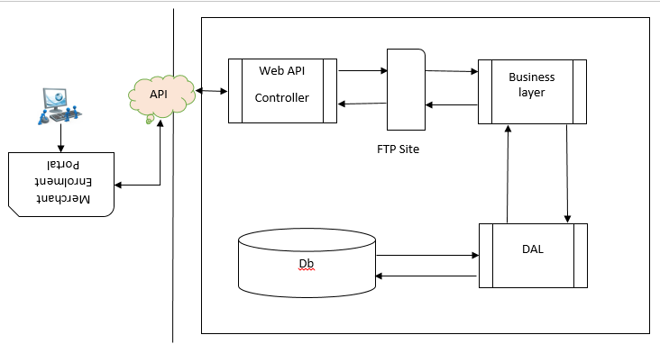

System Design

Design Method and Standards

Methods and standards to follow design them will be come here

Documentation Standards

Naming conventions
- Conventions for naming files, programs, modules, and possibly other structures such as variables and messages, should all be documented here.

Programming Standards
- This section should define the project programming standards. Whatever languages or standards are chosen, the aim should be to create a convenient and easily usable method for writing good-quality software. If an application development tool is used there may be other conventions that need to be defined, e.g. colour schemes.

Software development tools
- Visual Studio 2013

Outstanding Issues
- Provide details of any design issues that remain unresolved at the date of issue of this document. Explain options, pros and cons, and give an estimate of which option is most likely. Outline impact of each option on the rest of the design.

Decomposition Description
- The software components should be summarised. This should be presented as structure charts or object diagrams showing the hierarchy, control flow and data flow between the components.

Component Description

Component Identifier
- Each component should have a unique identifier. The identifiers to be used for components should be defined by the project and described elsewhere.

Type
- This section should describe the type of component, e.g. task, subroutine, subprogram, package, file.
- The contents of some component description sections depend on the component type. For the purpose of this template the categories: executable, i.e. contains computer instructions, or non-executable, i.e. contains only data, are used.

Purpose
- The purpose of a component should be defined by tracing it to the software requirements that it implements.
- Backwards traceability depends upon each component description explicitly referencing the requirements that justify its existence.

Function
- The function of a component must be defined in this document. This should a short description of what the component does and will depend upon the component type e.g. it may be a description of the process or of the data to be stored or transmitted.
- More detail will be provided in processing (see below).

Subordinates
- This section should list the modules that are ‘called by’ this component. The subordinates of a database could be the files that ‘compose’ it. The subordinates of an object are the objects that are ‘used by’ it.

Dependencies
- The dependencies of a component should be defined by listing the constraints placed upon its use by other components. For example:
- what operations have to have taken place before this component is called?
- what operations are excluded when this operation is taking place?
- what components have to be executed after this one?

Interfaces

Define the interfaces created for internal and external purpose

Resources
- The resources a component requires should be defined by itemising what the component needs from its environment to perform its function. Items that are part of the component interface are excluded. Examples of resources that might be needed by a component are displays, printers and buffers.

References
- Explicit references should be inserted where a component description uses or implies material from another document.

Processing
- The processing should be defined by summarising the control and data flow within it. For some kinds of component, e.g. files, there is no such flow. Techniques of process specification include Program Design Language, Pseudo Code and Flow Charts.
- Any specific algorithms to be used should be stated or referenced.

Data
- The data internal to a component should be defined. The amount of detail required depends strongly on the type of component. The logical and physical data structure of files that interface major components should be defined in detail.
- Data structure definitions must include the:
          - description of each element, e.g. name, type, dimension;
          - relationships between the elements, i.e. the structure;
          - range of possible values of each element;
          - Initial values of each element.

Software Requirements Traceability Matrix
- This section should contain a table that summarises how each software requirement has been met in this document. The tabular format permits one-to-one and one-to-many relationships to be shown.

System Req. Number | System Ref. Item | Component Identifier | Component Item

Document Control
Title: | Merchant Enrolment TDD
Issue: | Issue 1
Date:
Author:
Distribution:
Reference:
Filename:
Control:
Document Signoff
Nature of Signoff | Person | Signature | Date | Role
Authors
Reviewers
Document Change Record
Date | Version | Author | Change Details

